Great Rhombicuboctahedron

Definition
# Source: AI Source: Provided by: [Data Path: Persons Table -> ID Column: 1, Name_En Column: Motasem Essam] -> From: [ChatGPT] on [7/25/2026]
A Great Rhombicuboctahedron is a convex, uniform polyhedron and one of the 13 Archimedean solids. It is also known as the truncated cuboctahedron.
It has 26 faces consisting of:
- 12 square faces
- 8 regular hexagonal faces
- 6 regular octagonal faces
Its faces meet in the same arrangement at every vertex, with one square, one hexagon, and one octagon meeting at each vertex.
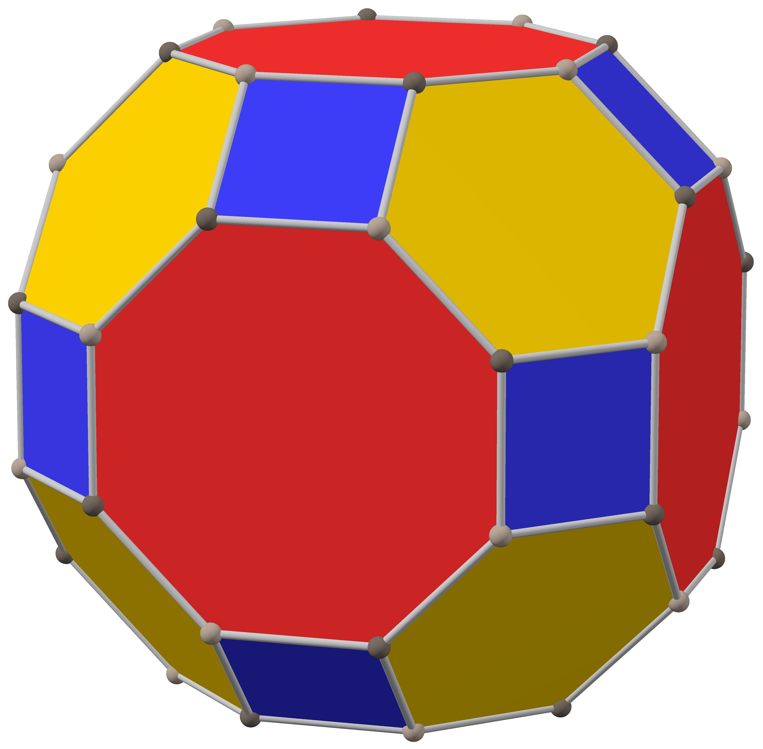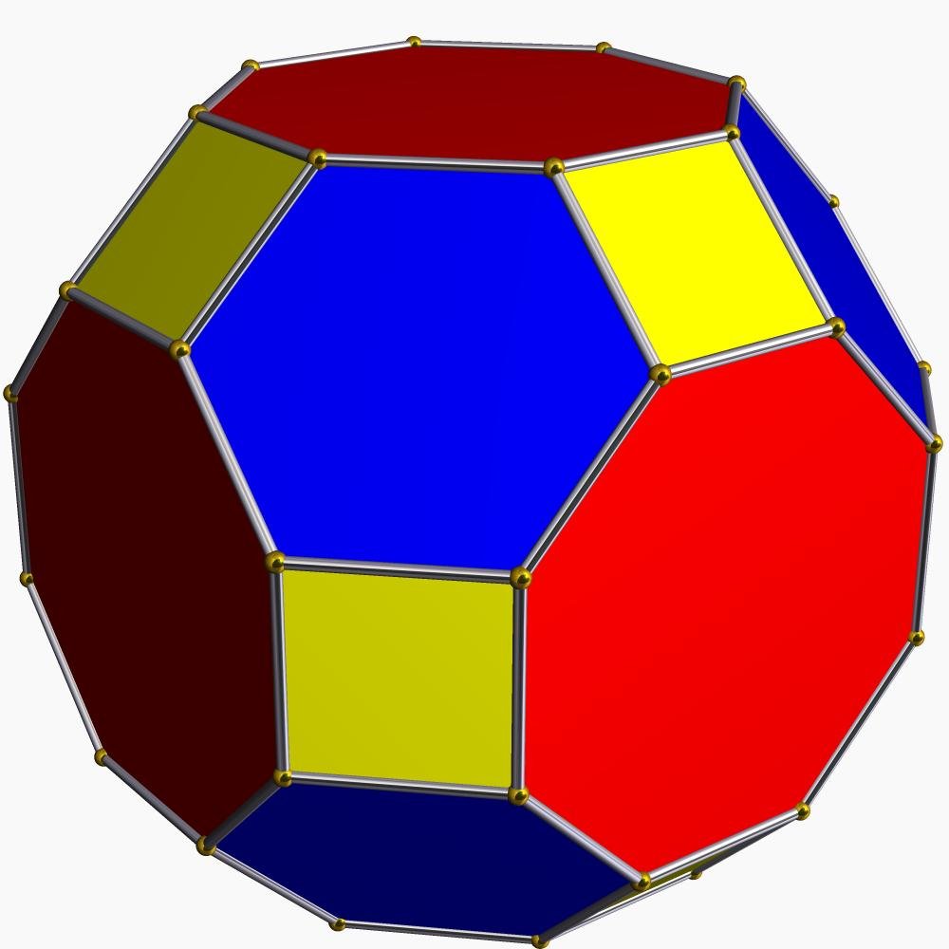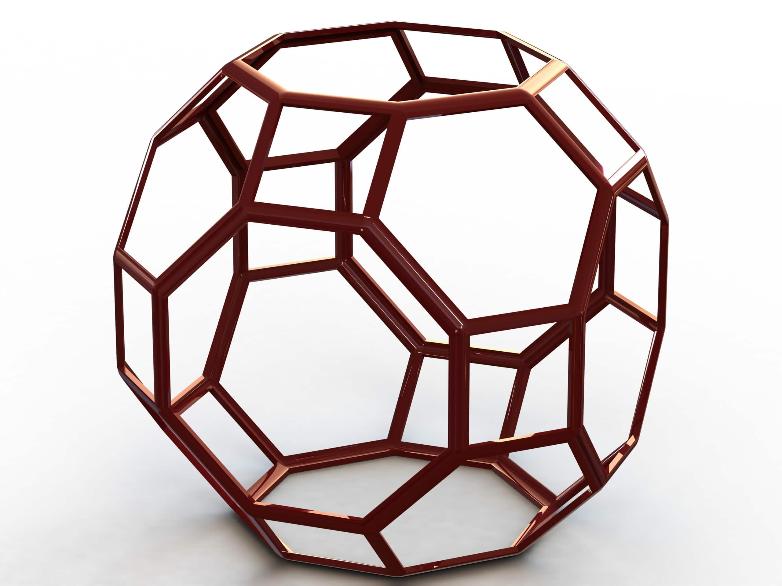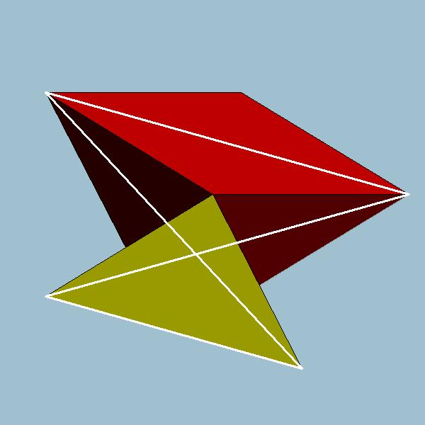

Simple Definition
# Source: AI Source: Provided by: [Data Path: Persons Table -> ID Column: 1, Name_En Column: Motasem Essam] -> From: [ChatGPT] on [7/25/2026]
A Great Rhombicuboctahedron is a 3D solid made of squares, hexagons, and octagons, arranged symmetrically so that three faces meet at every vertex.

Geometric Structure
# Source: AI Source: Provided by: [Data Path: Persons Table -> ID Column: 1, Name_En Column: Motasem Essam] -> From: [ChatGPT] on [7/25/2026]
The solid has a highly symmetrical structure:
- Topological shape: convex polyhedron.
- Faces: regular polygons of three different types.
- Vertex arrangement: one square, one hexagon, and one octagon meet at each vertex.
- Uniformity: every vertex has the same arrangement of faces, and the solid has identical edges and vertex geometry throughout.

Face Structure
# Source: AI Source: Provided by: [Data Path: Persons Table -> ID Column: 1, Name_En Column: Motasem Essam] -> From: [ChatGPT] on [7/25/2026]
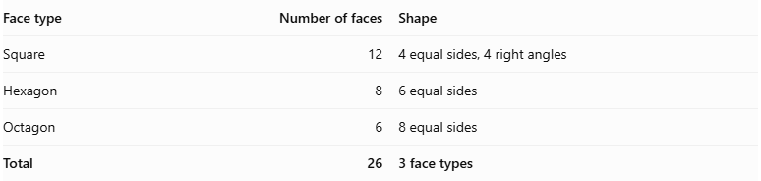
Face type | Number of faces | Shape
Square | 12 | 4 equal sides, 4 right angles
Hexagon | 8 | 6 equal sides
Octagon | 6 | 8 equal sides
Total | 26 | 3 face types
All faces are regular polygons, and all edges have the same length.

Edge Structure
# Source: AI Source: Provided by: [Data Path: Persons Table -> ID Column: 1, Name_En Column: Motasem Essam] -> From: [ChatGPT] on [7/25/2026]
The Great Rhombicuboctahedron has:
- 72 edges in total.
- All edges have equal length.
- Each edge is shared by exactly two faces.
- Edges connect the square, hexagonal, and octagonal faces.

Vertex Structure
# Source: AI Source: Provided by: [Data Path: Persons Table -> ID Column: 1, Name_En Column: Motasem Essam] -> From: [ChatGPT] on [7/25/2026]
The solid has 48 vertices.
At every vertex, three faces meet:
- One square.
- One regular hexagon.
- One regular octagon.
Its vertex configuration is:
$$\boxed{4.6.8}$$
This means that a square, hexagon, and octagon meet in sequence around every vertex.

Mathematical Properties
# Source: AI Source: Provided by: [Data Path: Persons Table -> ID Column: 1, Name_En Column: Motasem Essam] -> From: [ChatGPT] on [7/25/2026]
Faces (F)
26
Edges (E)
72
Vertices (V)
48
Vertex configuration
4.6.8
Euler's formula
$$V-E+F=2$$
$$48-72+26=\boxed{2}$$
Euler's formula verified
Other properties:
- It is convex.
- It is uniform.
- All faces are regular polygons.
- All edges are equal in length.
- All vertices are equivalent under its symmetries.
- It has octahedral symmetry, $O_{h}$.

Face Incidence
# Source: AI Source: Provided by: [Data Path: Persons Table -> ID Column: 1, Name_En Column: Motasem Essam] -> From: [ChatGPT] on [7/25/2026]
The three face types meet in the following arrangement:
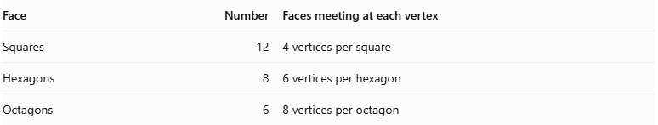
Face | Number | Faces meeting at each vertex
Squares | 12 | 4 vertices per square
Hexagons | 8 | 6 vertices per hexagon
Octagons | 6 | 8 vertices per octagon
Each vertex is shared by one square, one hexagon, and one octagon.

Surface Area and Volume
# Source: AI Source: Provided by: [Data Path: Persons Table -> ID Column: 1, Name_En Column: Motasem Essam] -> From: [ChatGPT] on [7/25/2026]
Let $a$ represent the common edge length.
Surface area
The total surface area is the sum of the areas of its 12 squares, 8 regular hexagons, and 6 regular octagons.
$$A=12A_{s}+8A_{h}+6A_{o}$$
Using the regular polygon area formulas:
$$A=12a^{2}+8\left(\frac{3\sqrt{3}}{2}a^{2}\right)+6\left(2(1+\sqrt{2})a^{2}\right)$$
Therefore:
$$\boxed{A=12(2+\sqrt{2}+\sqrt{3})a^{2}}$$
Volume
The volume depends on the edge length. For a regular great rhombicuboctahedron, it scales with the cube of the edge length:
$$V={ka}^{3}$$
where $k$ is a fixed geometric constant for this particular solid.

Symmetry
# Source: AI Source: Provided by: [Data Path: Persons Table -> ID Column: 1, Name_En Column: Motasem Essam] -> From: [ChatGPT] on [7/25/2026]
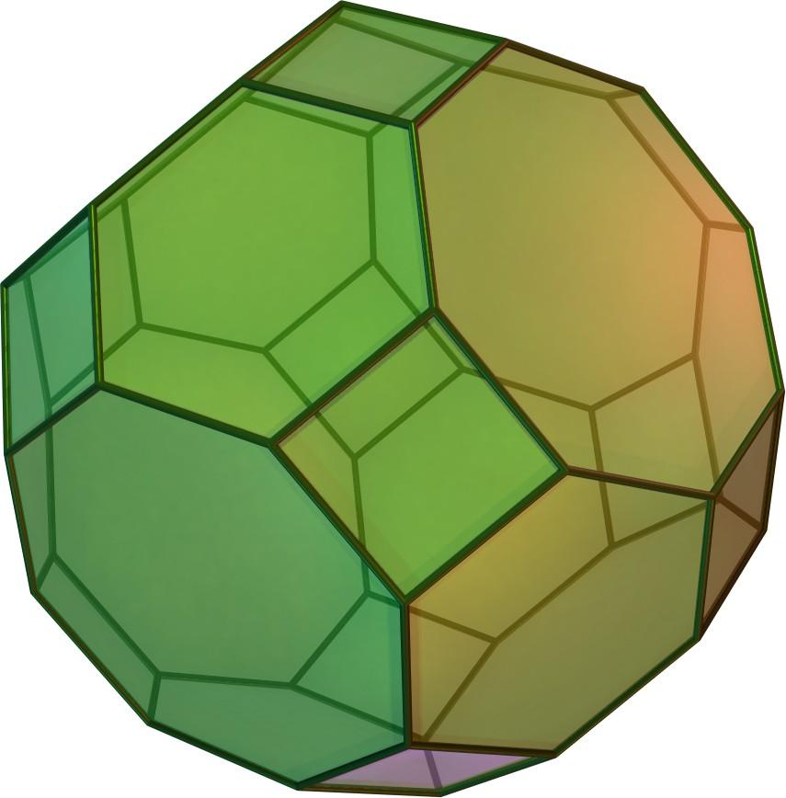
The Great Rhombicuboctahedron has octahedral symmetry, represented by $O_{h}$.
Its symmetry includes:
- Rotational symmetry around several axes.
- Reflection symmetry across multiple planes.
- Central inversion symmetry.
- A highly regular arrangement of faces, edges, and vertices.
Its full symmetry group has 48 symmetry operations.

Relationship to Other Solids
# Source: AI Source: Provided by: [Data Path: Persons Table -> ID Column: 1, Name_En Column: Motasem Essam] -> From: [ChatGPT] on [7/25/2026]
The Great Rhombicuboctahedron belongs to the Archimedean solids.
It is related to several other polyhedra:
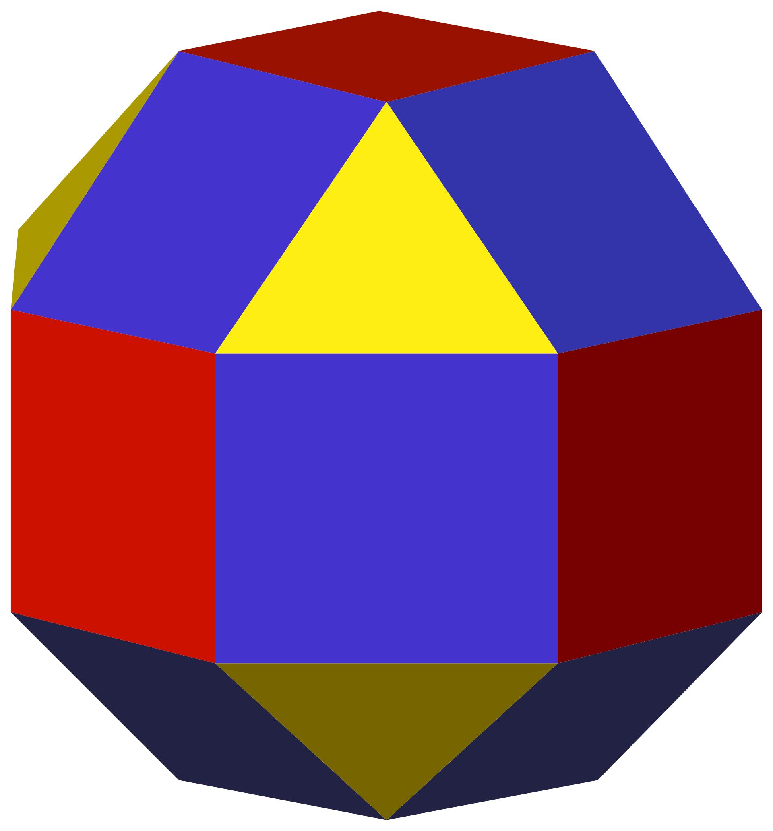
Small Rhombicuboctahedron
A different Archimedean solid with 8 triangular faces and 18 square faces.
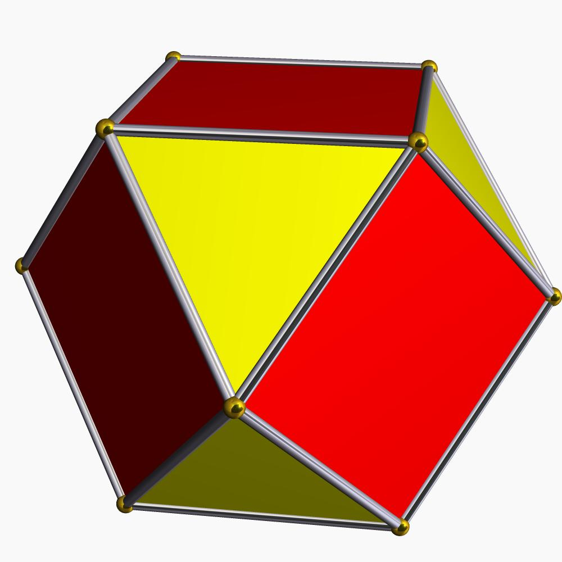
Cuboctahedron
A polyhedron with 8 triangular faces and 6 square faces.
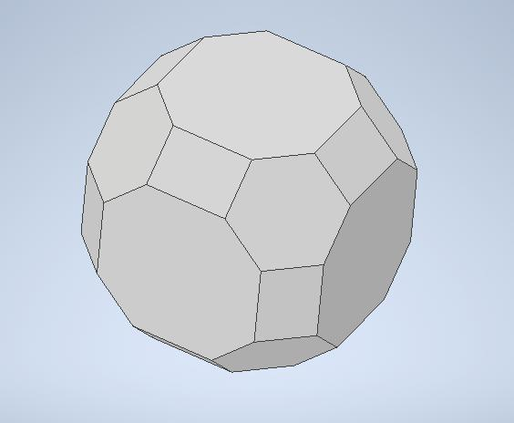
Truncated Cuboctahedron
A related name often used for the Great Rhombicuboctahedron, although some mathematical references distinguish the terminology and prefer rhombitruncated cuboctahedron for this solid.
Terminology note: Wolfram MathWorld identifies “truncated cuboctahedron” as an improper alternative name for the Great Rhombicuboctahedron.

Worked Example
# Source: AI Source: Provided by: [Data Path: Persons Table -> ID Column: 1, Name_En Column: Motasem Essam] -> From: [ChatGPT] on [7/25/2026]
Question: A Great Rhombicuboctahedron has an edge length of 2 cm. Find its total number of faces, edges, and vertices.
Solution:
From its standard geometric properties:
- Faces: $F=26$
- Edges: $E=72$
- Vertices: $V=48$
Verify Euler's formula:
$$V-E+F=48-72+26=2$$
Answer verified

Constructing a Great Rhombicuboctahedron

Geometric Instruments Used
# Source: AI Source: Provided by: [Data Path: Persons Table -> ID Column: 1, Name_En Column: Motasem Essam] -> From: [ChatGPT] on [7/25/2026]
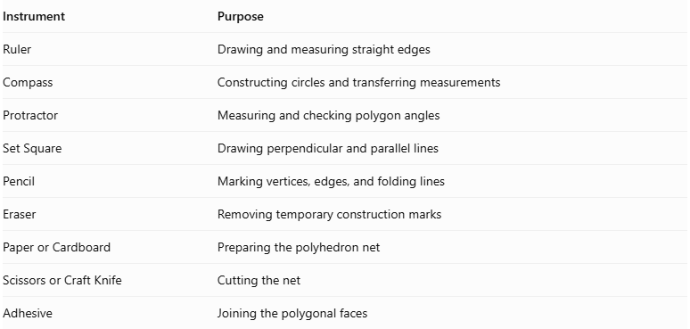
Instrument | Purpose
Ruler | Drawing and measuring straight edges
Compass | Constructing circles and transferring measurements
Protractor | Measuring and checking polygon angles
Set Square | Drawing perpendicular and parallel lines
Pencil | Marking vertices, edges, and folding lines
Eraser | Removing temporary construction marks
Paper or Cardboard | Preparing the polyhedron net
Scissors or Craft Knife | Cutting the net
Adhesive | Joining the polygonal faces

Instrument-Based Construction Procedures

Method 1: Construction Using a Polygonal Net
# Source: AI Source: Provided by: [Data Path: Persons Table -> ID Column: 1, Name_En Column: Motasem Essam] -> From: [ChatGPT] on [7/25/2026]
Step 1: Determine the Edge Length
- Select a common edge length $a$.
- Use the same measurement for every polygon.
- Prepare the ruler and compass to maintain consistent dimensions.
Step 2: Construct the Square Faces
- Draw 12 regular squares.
- Each square must have four equal sides of length $a$.
- Each interior angle must measure ${90}^{°}$.
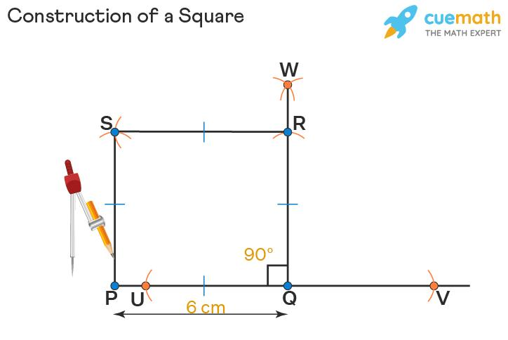
Step 3: Construct the Hexagonal Faces
- Draw 8 regular hexagons.
- Each hexagon must have six equal sides of length $a$.
- Each interior angle must measure ${120}^{°}$.
- Use a compass to transfer the same side length around the polygon.
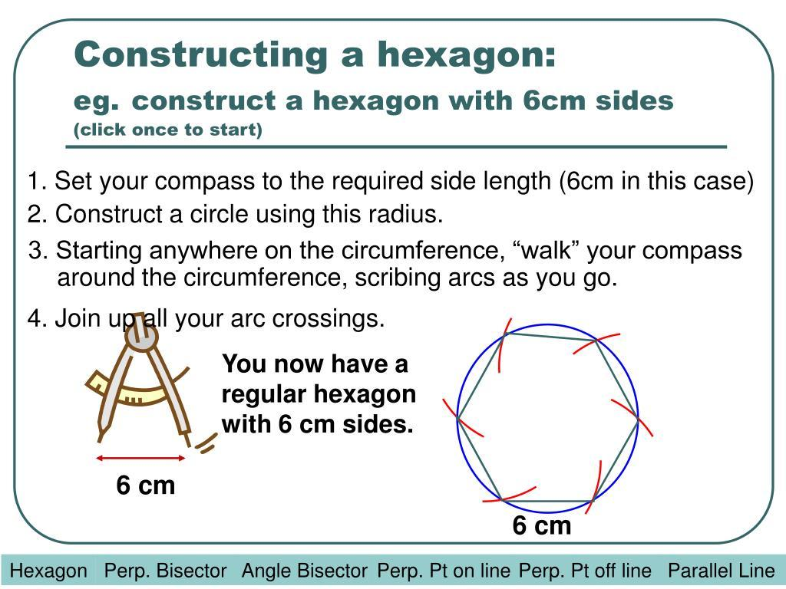
Step 4: Construct the Octagonal Faces
- Draw 6 regular octagons.
- Each octagon must have eight equal sides of length $a$.
- Each interior angle must measure ${135}^{°}$.
- Use a protractor to verify the angles and a ruler to maintain equal side lengths.
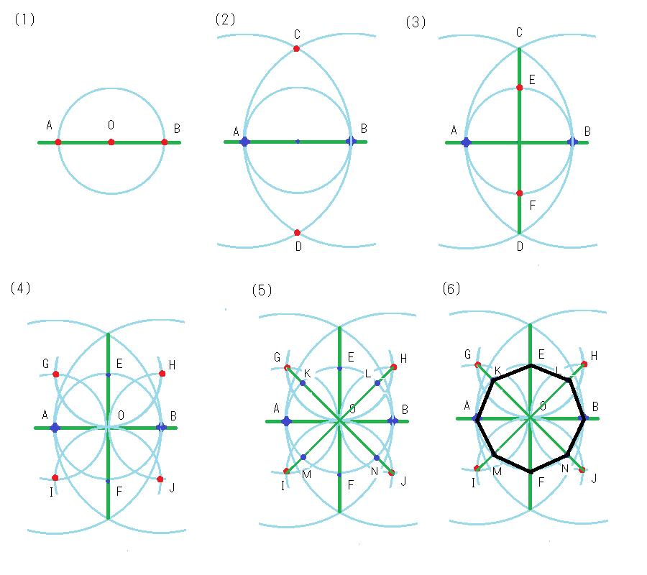
Step 5: Arrange the Polygonal Faces
- Arrange the 12 squares, 8 hexagons, and 6 octagons according to the Great Rhombicuboctahedron net.
- Ensure that the faces are connected along matching edges.
- Maintain the correct face adjacency so that every completed vertex has the $4.6.8$ arrangement.
- Add joining tabs to selected outer edges.
Step 6: Cut Out the Net
- Cut around the outside boundary of the complete net.
- Preserve the joining tabs.
- Avoid cutting along the internal folding lines.
Step 7: Fold the Polygonal Faces
- Fold along the shared edges.
- Raise the polygonal faces gradually.
- Bring the corresponding edges together to form the three-dimensional structure.
Step 8: Join the Faces
- Apply adhesive to the joining tabs.
- Connect the corresponding polygonal edges.
- Allow the structure to hold its shape.
Step 9: Complete the Solid
- Check that all 26 faces are correctly assembled.
- Verify that all edges have equal lengths.
- Confirm that every vertex joins one square, one hexagon, and one octagon.
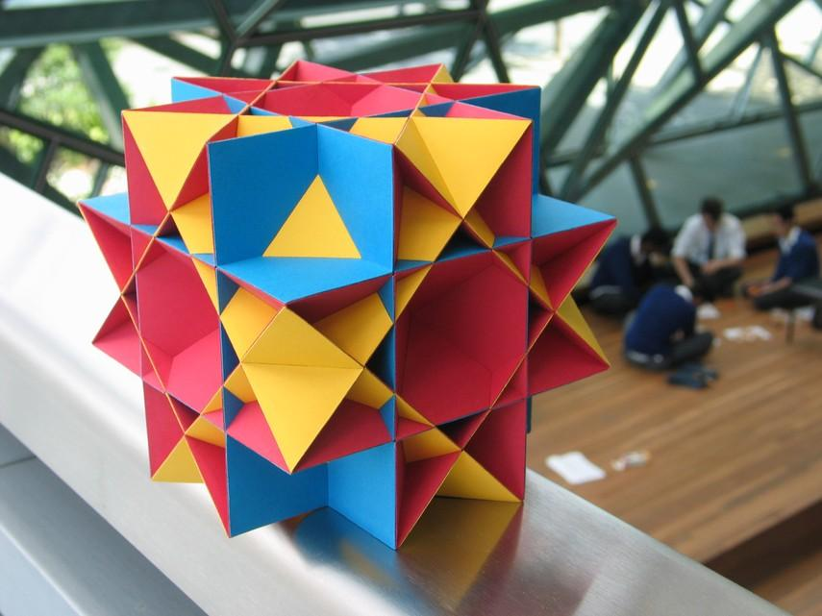

Method 2: Construction Using a Truncated Cuboctahedron
# Source: AI Source: Provided by: [Data Path: Persons Table -> ID Column: 1, Name_En Column: Motasem Essam] -> From: [ChatGPT] on [7/25/2026]
The Great Rhombicuboctahedron is also described as a Rhombitruncated Cuboctahedron. Its construction can be understood through the truncation and expansion of a cuboctahedral structure.
Step 1: Construct the Cuboctahedral Framework
- Prepare a cuboctahedral reference model.
- Identify its square faces, triangular faces, edges, and vertices.
Step 2: Establish the Truncation Structure
- Mark the positions where the original edges and vertices will be modified.
- Use a ruler and compass to maintain equal construction measurements.
- Maintain the symmetry of the original framework.
Step 3: Construct the Expanded Polygonal Faces
- Develop the square, hexagonal, and octagonal face arrangement.
- Ensure that the resulting polygons have a common edge length.
- Arrange the faces according to the $4.6.8$ vertex configuration.
Step 4: Assemble the Structure
- Connect the polygonal faces along their corresponding edges.
- Verify that the resulting solid is convex and has the correct face arrangement.
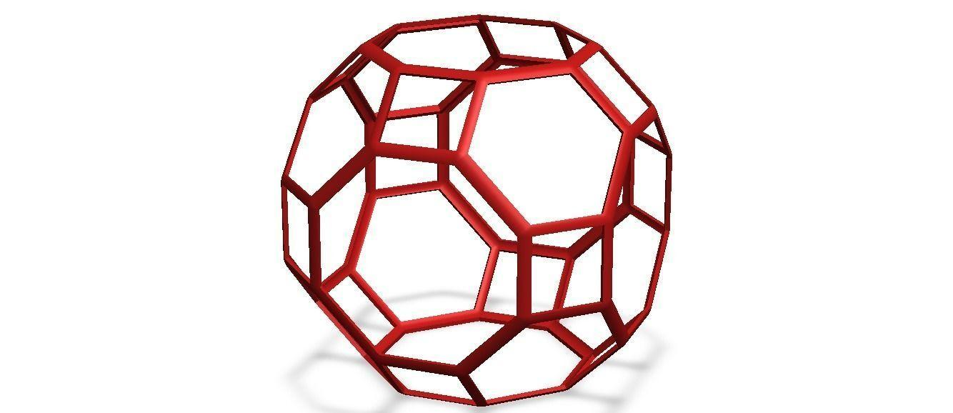

Key Points
# Source: AI Source: Provided by: [Data Path: Persons Table -> ID Column: 1, Name_En Column: Motasem Essam] -> From: [ChatGPT] on [7/25/2026]
- The Great Rhombicuboctahedron is an Archimedean solid.
- It has 26 faces.
- It contains 12 squares, 8 hexagons, and 6 octagons.
- It has 72 edges.
- It has 48 vertices.
- Its vertex configuration is $4.6.8$.
- All edges have equal length.
- It has octahedral symmetry $O_{h}$.
- It satisfies Euler's polyhedron formula.

Conclusion
# Source: AI Source: Provided by: [Data Path: Persons Table -> ID Column: 1, Name_En Column: Motasem Essam] -> From: [ChatGPT] on [7/25/2026]
The Great Rhombicuboctahedron is a highly symmetrical Archimedean solid composed of squares, hexagons, and octagons. Its distinctive $4.6.8$ vertex configuration, 26 faces, 72 edges, and 48 vertices make it an important example of a uniform polyhedron.

References
# Source: AI Source: Provided by: [Data Path: Persons Table -> ID Column: 1, Name_En Column: Motasem Essam] -> From: [ChatGPT] on [7/25/2026]
- Wolfram MathWorld – Great Rhombicuboctahedron.
- Wolfram MathWorld – Archimedean Solid.
- Polydron – Archimedean Solids Work Cards.
- The Thirteen Archimedean Solids – University of North Carolina Wilmington.

